COMP_SCI-5525-CLOUD_COMPUTING

Assignment-3

**Sowmya Patlolla**

1. **Deploying a static website on Microsoft Azure using a Virtual Machine**

**Website URL:** [**http://20.213.93.247/**](http://20.213.93.247/)

Step 1: Open the Azure cloud portal and then click on Virtual machines.

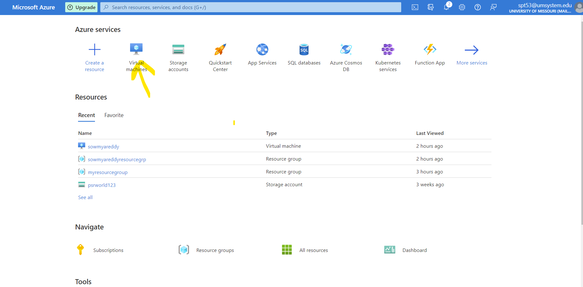

Step 2: Now create a VM by clicking on create Azure virtual machine.

Step 3: Create a virtual machine with following details.

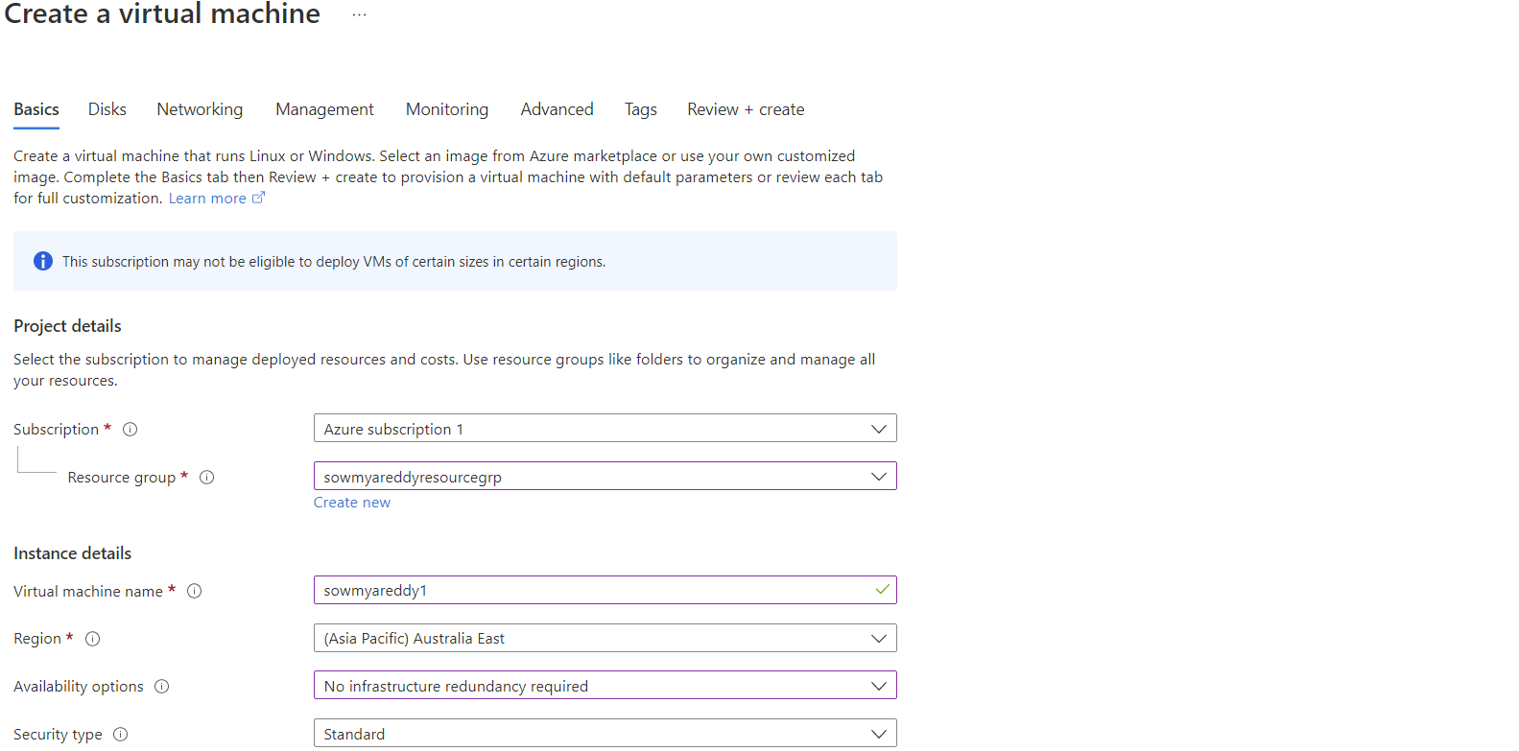

Step 4: After entering all the required configurations click on Review create button to create virtual machine.

Step 5: View the created virtual machine by selecting the virtual machines in the home page.

Step 6: Now click on the selected VM and click on connect then select SSH.

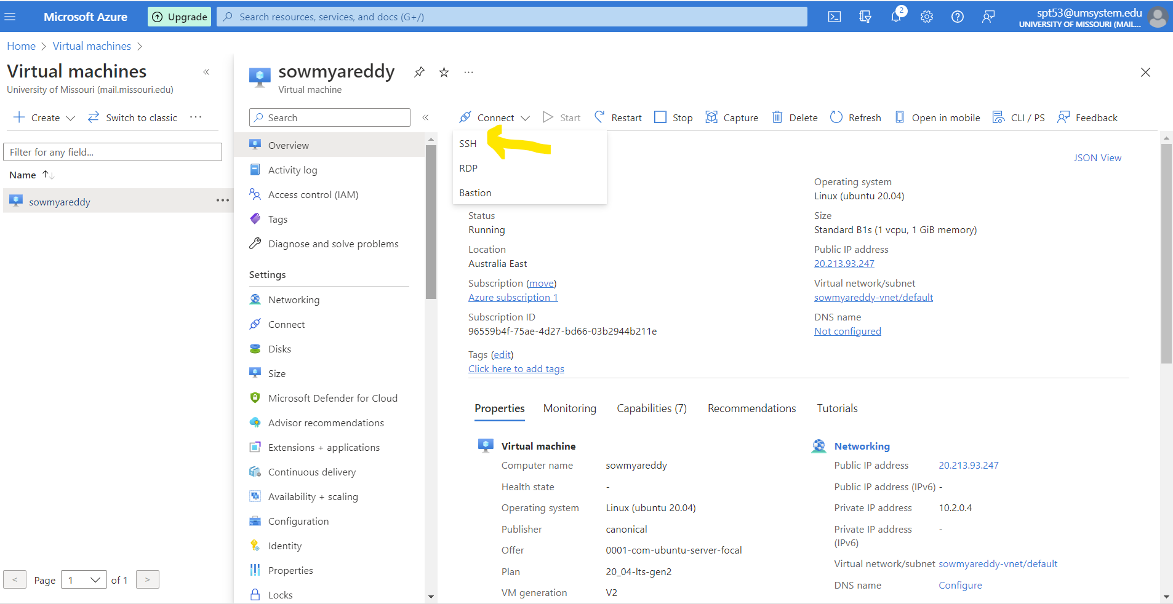

Step 7: Connect to the SSH through power shell in windows by copy the following command from created virtual instance page.

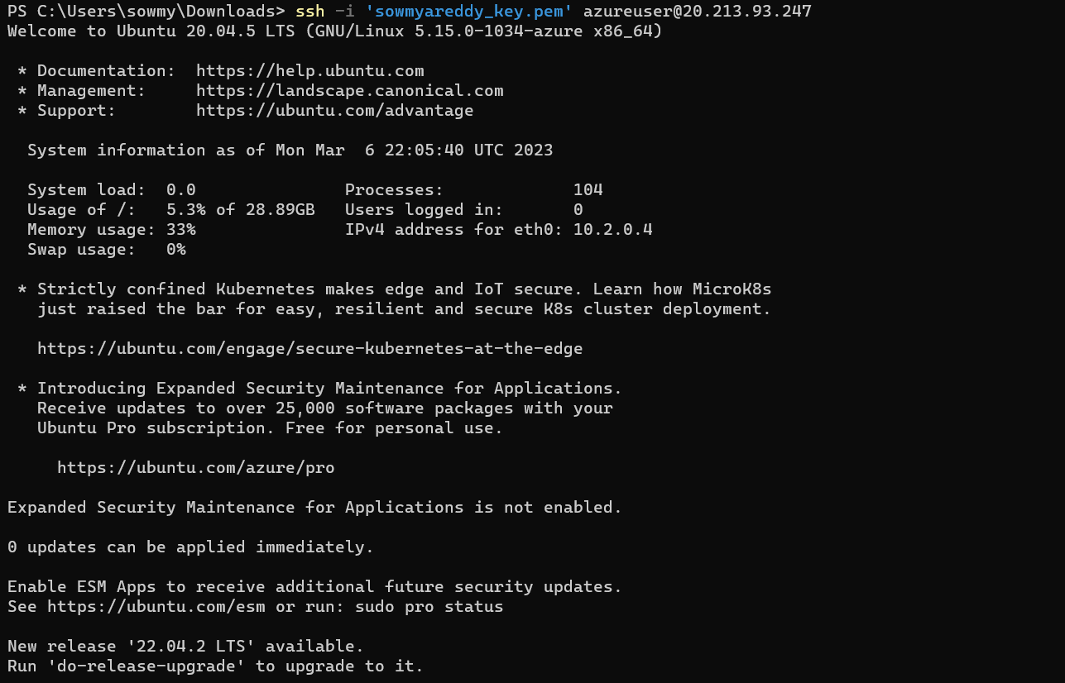

Step 8: After connecting to the SSH, install the apache2 server to host the static website by the following command.

Step 9: Go to the html file path and fetch the static website html file by the providing the following command.

Step 10: Write the required code for the static website. My index file contains the following code.

Step 11: Access the static website by clicking on the public address provided in the created virtual machine page.

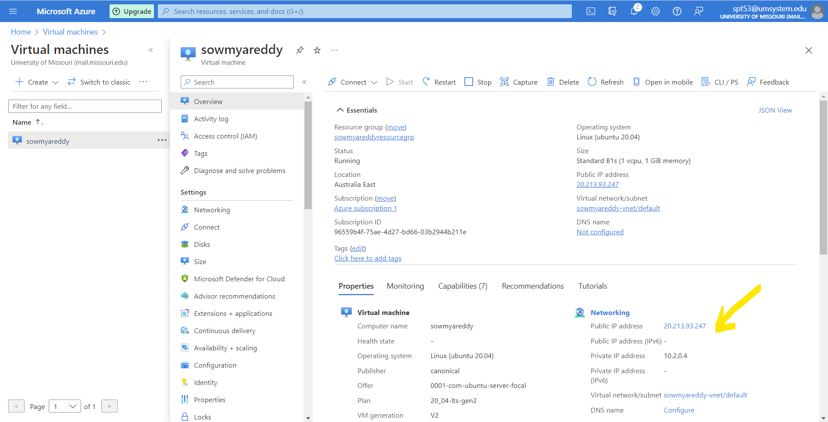

Step 12: Test the static website by the following URL.

**Website URL:** <http://20.213.93.247/>

**2.Deploying a static website on GCP using a Virtual Machine**

**Website URL:** [**http://34.125.16.158/**](http://34.125.16.158/)

Step1: Create and setup Google Cloud Platform account and login to it.

Step 2: Go to the compute engine and select VM instances to create a virtual machine.

Step 3: Click on create instance to create a virtual machine instance.

Step 4: Give a name to VM and select the required region, zone and configurations based on our requirement.

Step 5: Select both firewall options to allow http traffic and then click on create button.

Step 6: Below image shows where created instances will be visible.

Step 7: Connecting to the virtual machine by clicking on the SSH. It opens the SSH terminal in new tab.

Step 8: Install the following command to install the Apache web server.

Step 9: Go to the html file path and fetch the static website html file by the providing the following command.

Step 10: Write the required code for the static website. My index file contains the following code.

Step 11: Access the static website by clicking on the public address provided in the created virtual machine page.

Step 12: Test the static website by the following URL.

Website URL: <http://34.125.16.158/>

**3. Deploying a static website on AWS using a Virtual Machine and Docker Container**

**Website URL:**[**http://54.144.46.217/My_Page.html**](http://54.144.46.217/My_Page.html)

Step 1: Open the AWS console and then click on the EC2 instance to create a virtual machine instance.

Step 2: Click on launch instance button to create an amazon EC2 instance.

Step 3: Now give the name to the instance and select application and OS image as Ubuntu.

Step 4: For the key pair, click on the create new key pair option then it generates a unique key to access the EC2 instance and check all the firewall options provided in the page to access the static website and then click on launch instance option to create instance.

Step 5: Following is the created EC2 instance.

Step 6: Click on the created EC2 instance and then go to connect to instance and then select the SSH client.

Step 7: Enter the following command in the power shell to connect to the SSH.

ssh -i "sowmya_aws_key.pem" ubuntu@ec2-54-144-46-217.compute-1.amazonaws.com

Step 8: Install the following command to install the Apache web server.

Step 9: Go to the html file path and fetch the static website html file by the providing the following command.

Step 10: Write the required code for the static website. My index file contains the following code.

Step 11: Access the static website by clicking on the public address provided in the created EC2 instance page.

Step 12: Test the static website by the following URL.

Website URL: <http://54.144.46.217/My_Page.html>

**Deploying the static website using Docker Container image in AWS cloud:**

Step 1: Installing the docker container image using the following command.

Step 2: Building an image from Docker file using the following command.

Step 3: Run the docker image using the following command.



Step 4: Use the following curl command to check the response of the port 40:80.

Step 5: Checking the status of the Apache web server by using the following command.

Step 6: Click on the public Ip address provided in the EC2 instance page to test the static website.

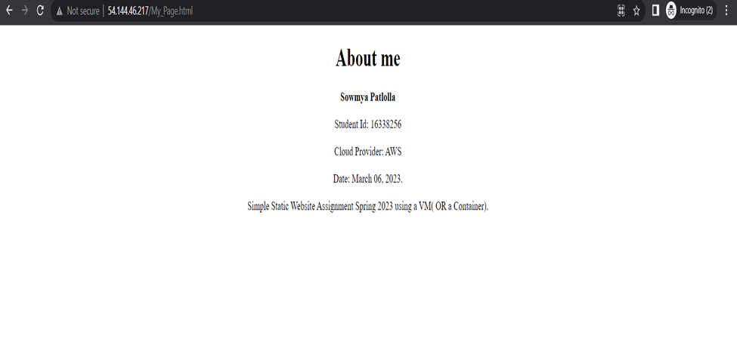

**4.Epilog**

**Lessons learnt**:

Public clouds such as AWS, GCP, and Azure offers various services that can be used to deploy and manage static websites, such as virtual machines, container registries, load balancers, and content delivery networks.

Deploying a static website using virtual machines or containers in public clouds requires writing scripts or configuration files that describes the need of the infrastructure to run the website. This can teach us the importance of Infrastructure as Code and how it can help us to manage and automate the deployment and scaling of our applications. It also teaches us the importance of cost optimization. By choosing the right instance types, storage options, and network configurations, we can reduce the cost of running our application while maintaining performance and reliability. Using containers to deploy a static website can help us to package the website and its dependencies in a portable format. It can teach us the benefits of using containerization and it simplifies the application deployment and management.

**Fun Part:**

One of the enjoyable aspects of the task was exploring various cloud services and learning about their potential. I had a lot of fun exploring the many features and services that various cloud service providers, such as Amazon, Azure, and GCP, offer. As a result, I compared the functionality of cloud services provided by each of the cloud provider.

**Challenging Part:**

It can be difficult to set up and configure the virtual machines, especially if we are unfamiliar with the cloud platform or the operating system that the virtual machine is using. Web servers, databases, SSL certificates, and other software components would have to be manually installed and configured, which can be time-consuming and error-prone.